Port Security

Configuring Port Security & Switchport Security Configuration

Inacio Andre

2024

* By default, all interfaces on a Cisco switch are turned on. That means that an attacker could connect to your network through a wall socket and potentially threaten your network. If you know which devices will be connected to which ports, you can use the Cisco security feature called **port security**. By using port security, a network administrator can associate specific MAC addresses with the interface, which can prevent an attacker to connect his device. This way you can restrict access to an interface so that only the authorized devices can use it. If an unauthorized device is connected, you can decide what action the switch will take, for example discarding the traffic and shutting down the port.

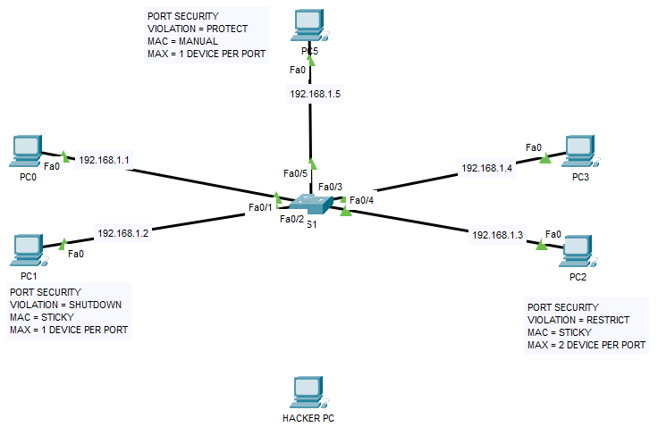

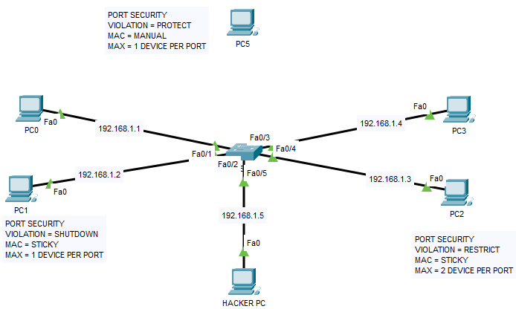

S1

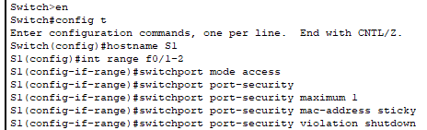

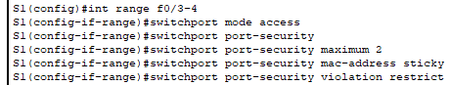

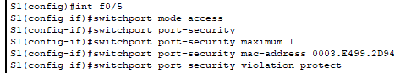

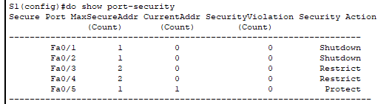

From PC0 TO PC2

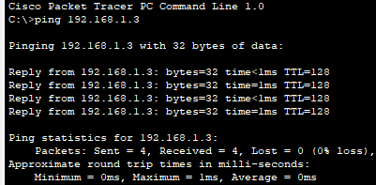

From PC0 TO PC3

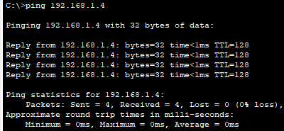

From HACKER PC TO PC3, Using fa0/5

